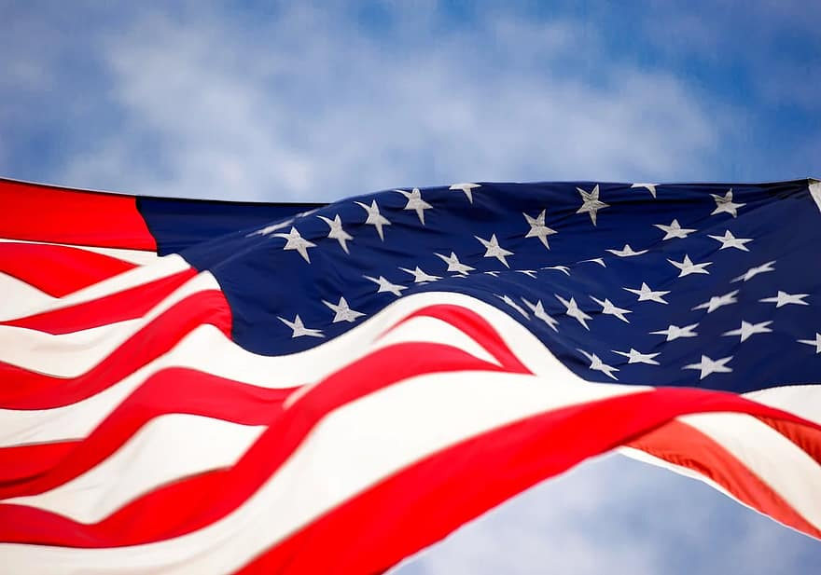
Little Valley Hometown Heroes
Please provide: Any of the information below (Does not have to be ALL)
Veteran’s Name:__________________________________
Branch:_________________________________________
Rank:___________________________________________
Years of Service:_________________________________
Medals:_________________________________________
Sponsored by:____________________________________
Address and phone number please:________________________
Banners will be 30x60”. Price of banner and hardware to hang is $150.00
Deadline: June 10, 2022 In order to get them hung for July 4th.
Please send form with picture of veteran (preferably in uniform) and check made payable to: Little Valley VFW Auxiliary 8734 .

Forms may be left at VFW Post or mailed to: Chris Leavor, Treasurer: 2027 Cemetery Hill
Franklinville, NY 14737
Questions? Call Chris- 676-2400 or email CAL2027@hotmail.com
Please enclose a stamped self-addressed envelope so we can return pictures**Please note that we cannot be responsible for damage due to weather or circumstances beyond our control. Family will be responsible to replace broken brackets or damaged banners if they need to be repaired or rehung.

